Alteration guide to Online Formals E-Commerce App

V1.0

**Table of Contents**

Cover Page 1

Table of Contents 2

Introduction 3

List of Materials Needed 3

Getting Started 3

Making alterations to homepage Content:  
Top skinny ad banner 6

Carousel 8

Three wide ad boxes 11

4 tall ad boxes 14

Making alterations to category pages:

Main carousel top images 16

Finishing Your Changes, Saving, and Syncing 16

Proper Syntax For Links 18

**Introduction**

This guide is meant to serve as an instruction manual for Online Formal employees to be able to make link and image changes to designated areas within the app. Although many of the controls are contained within the admin UI for most product and category options/controls, in some cases a change will be required to be made to code for the app. For these cases, instructions will be provide in this manual so as to minimize confusion about how these changes can be made to the code. Each section will contain the step by step instructions on how these alterations can be done and must be followed in their exact order. Failure to do so may results in undesired results. Please refer to the table of contents for page in which your desired process begins. Always refer to the list of materials needed and getting started sections BEFORE beginning work on any changes as failure to include these steps before beginning any changes will results in either your changes getting de-synchronized/lost or overwriting existing code, which can be disastrous. This guide is updated regularly and will contain up to date procedures for completing your changes. Please check your project repo for the most up to date version of this guide before starting with any changes to ensure you are performing the correct process. The version number in the cover page will provide the indication of what version of this guide you are using.

**List of Materials Needed**

To get started you will need the following items and software:

* Github client: can be downloaded from <http://windows.github.com/> for windows or <http://mac.github.com/> for mac users.
* An html/css text editor of your choice. If you do not have one or do not know what this is, I recommend downloading notepad++ as it is lightweight, and very easy to use and understand. You can download this for free at: <http://notepad-plus-plus.org/>
* Access to the Podio Workspace. This will be needed so that you can access the webhooks and sync your work from the github repository to your live site.

**Getting Started**

Once you have the above mentioned items, you are ready to get started. Before you start making any changes FOLLOW THESE STEPS FIRST!

1. Start up the Github client.
2. Your screen should look something like this:  
   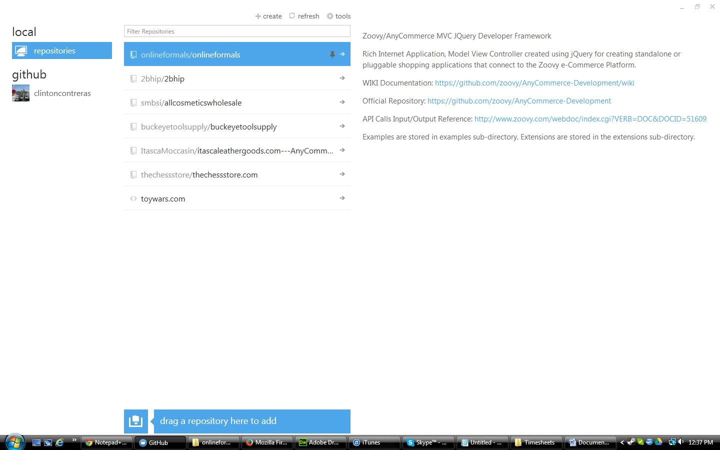
3. Click on the onlineformals repo. If it does not appear for you, please click your account icon under github, refresh the repo list, find onlineformals repo and clone it. If onlineformals is not appearing for you, please contact Zoovy so we can get that setup for you.
4. Your screen should now look something like this:  
   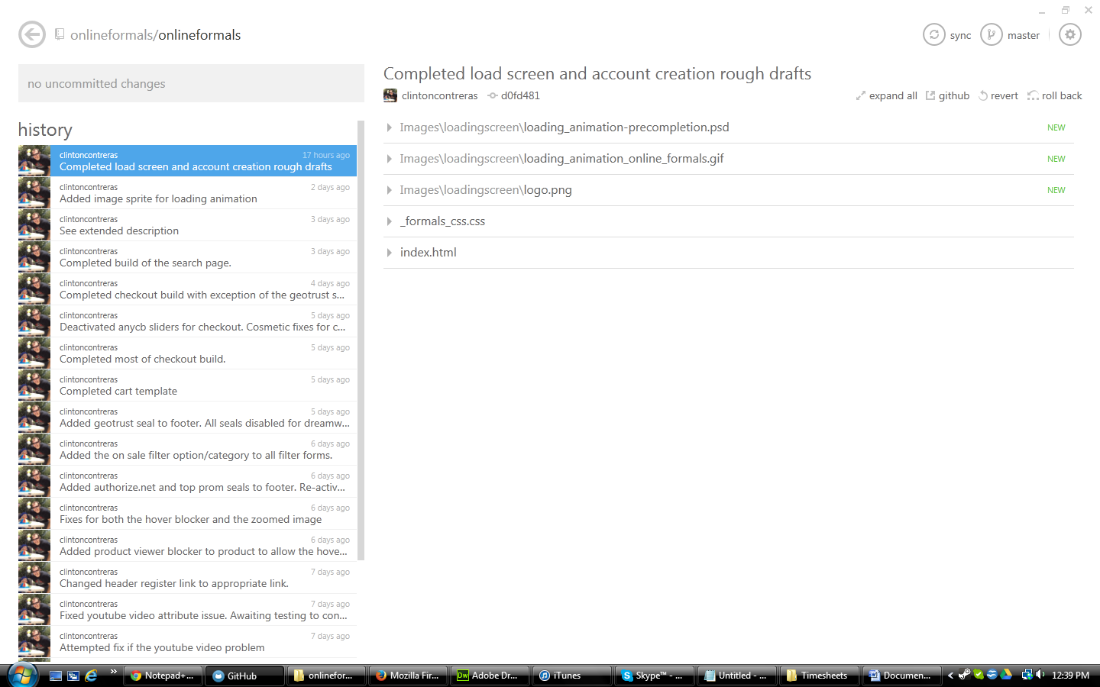
5. Click the sync button. It should be with the rest of the buttons in the top right hand corner of the client.
6. Once the sync has completed, you should now have the most up to date version of the app.
7. Sign onto podio and make a post in the online formals workspace that you are accessing and changing the app code. This is done so that any dev that might be working in it at that time knows to sync their changes and halt any work they are doing so that you both don’t have de-synchronization issues.
8. Wait a few minutes and sync the repo one more time to make sure any changes the devs might have been working on are included in your most up to date version, and so you don’t unintentionally cause them to lose all the work they were working on.
9. Click the button in the top right hand corner that looks like a gear and click the option: open in explorer.
10. The online formals repo folders/files should now be visible and are ready to receive your changes. Refer to the correct section in the table of contents on how to make changes to your desired section.

**Homepage: Top Skinny Banner Ad Bar**

The following steps are for changing the image and link for the Homepage top skinny ad bar. The red box indicates where this area is located on the app site:  
 

1. In your repo folder, look for a file titled index.html. right-click and/or open this file with your code editor of choice. For notepad++, you should be able to right click the file > open with > notepad++ . Your screen should look something like this:

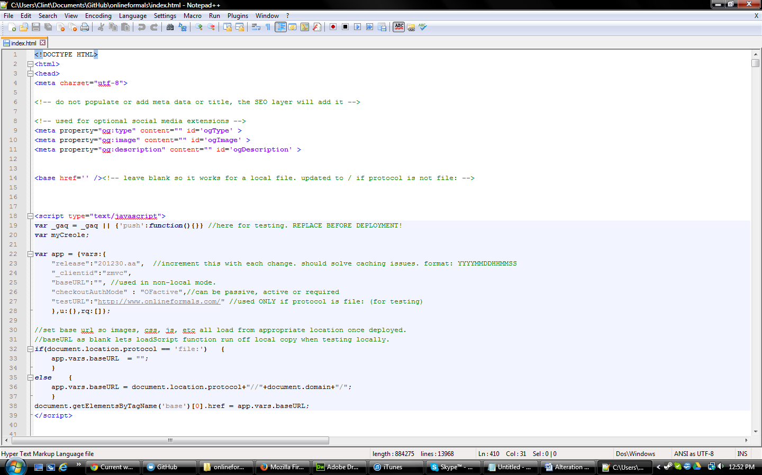

1. Press ctrl + f. The find feature should come up. Type in homepageBannerContainer and hit enter.
2. You should now be in a section that looks something like this. The highlighted area should be the only area you will need to modify:  
   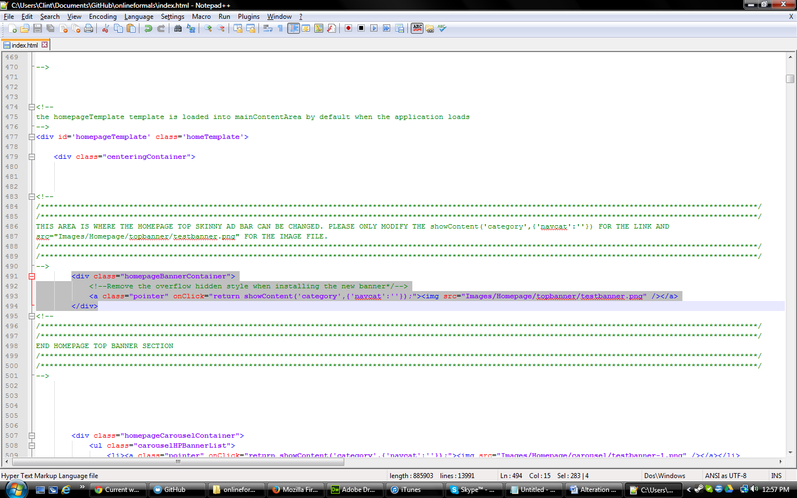
3. To change the banner image and link location:
   1. Open up the following folders: images > Homepage > topbanner.
   2. Drop your image file into this folder. Take note of the images name and file type (i.e. .png, .jpeg, etc). Be sure to NOT allow any spaces in the name of this image or your image will not load in the code.
   3. Return to your code editor, press ctrl + f and type in homepageBannerContainer and press enter.
   4. To change the link location:
      1. In the <a line, look for a snippet that looks something like this : onClick="return showContent('category',{'navcat':''});" . Where it says: 'navcat':'' add the navigation path for the category page you want displayed. For example, if you wanted the designers.BG Haute category, you would change this line to: 'navcat':'.designers.bg_haute' .
      2. Refer to Proper Syntax section for more instructions on how to change the link for linking to pages other than a category page.
   5. To change the image:
      1. In the <img line, look for a snippet that looks something like this : src="Images/Homepage/topbanner/testbanner.png (or whatever name is currently there)" . Since you stored your image in the same place that all images go, all you need to change is the testbanner.png (or whatever name is currently there) part of the code. Change this code to whatever your image is named .file type . For example, if the file is called christmasbanner and it is a .png file type, you would input it as christmasbanner.png .
   6. Your changes are done. Refer to the table of contents for the next section you need to make changes to OR Finishing Your Changes, Saving, and Syncing section if you are completed with your changes.

**Homepage: Carousel**

The following steps are for changing the image and link for the Homepage Carousel. The red box indicates where this area is located on the app site:

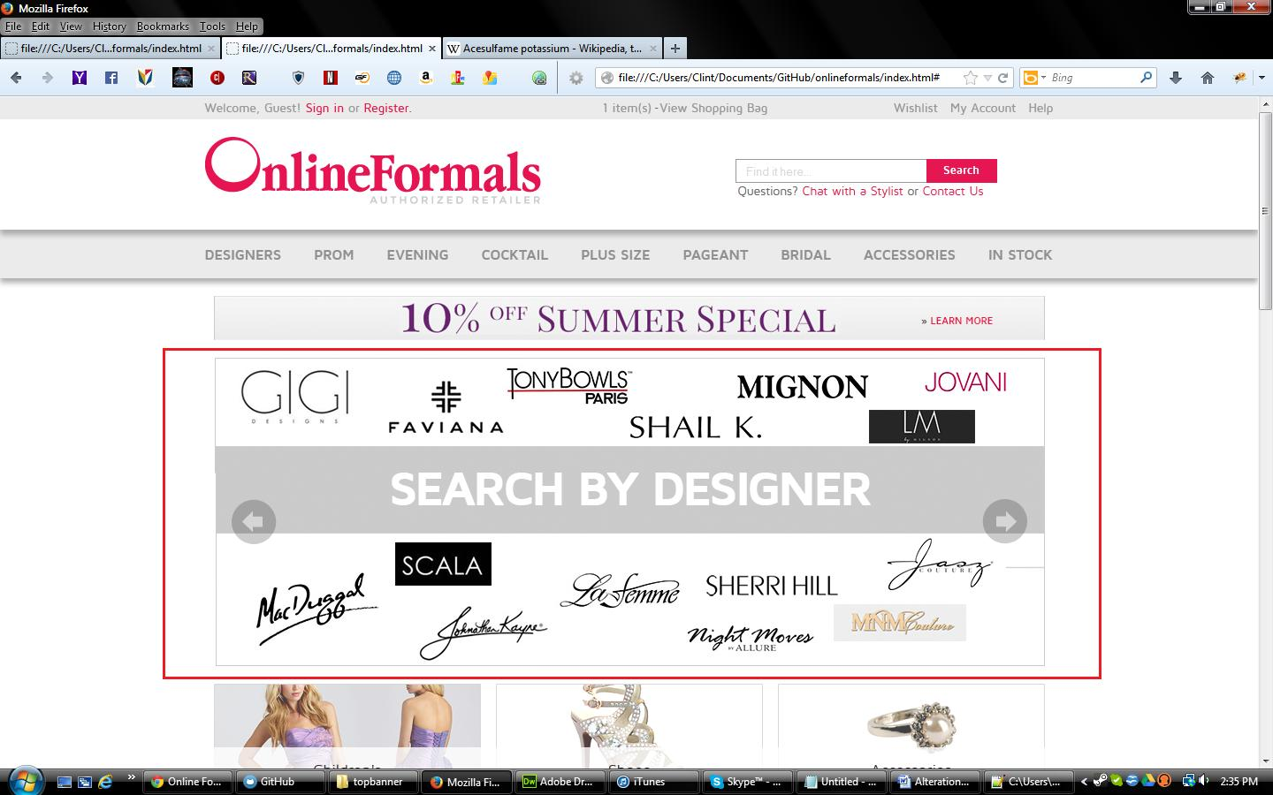

1. In your repo folder, look for a file titled index.html. right-click and/or open this file with your code editor of choice. For notepad++, you should be able to right click the file > open with > notepad++ . Your screen should look something like this:  
   
2. Press ctrl + f. The find feature should come up. Type in homepageCarouselContainer and hit enter.
3. You should now be in a section that looks something like this. The highlighted area should be the only area you will need to modify:  
   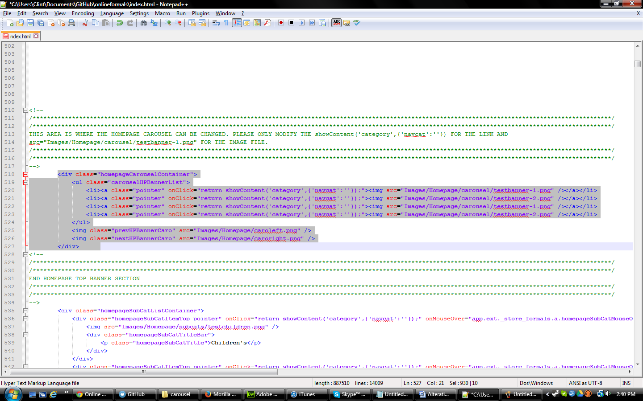
4. To change the banner image and link location:
   1. Open up the following folders: images > Homepage > carousel.
   2. Drop your image file into this folder. Take note of the images name and file type (i.e. .png, .jpeg, etc). Be sure to NOT allow any spaces in the name of this image or your image will not load in the code.
   3. Return to your code editor, press ctrl + f and type in homepageCarouselContainer and press enter.
   4. To change the link location:
      1. In the <li><a line, look for a snippet that looks something like this : onClick="return showContent('category',{'navcat':''});" . Where it says: 'navcat':'' add the navigation path for the category page you want displayed. For example, if you wanted the designers.BG Haute category, you would change this line to: 'navcat':'.designers.bg_haute' .
      2. Refer to Proper Syntax section for more instructions on how to change the link for linking to pages other than a category page.
   5. To change the image:
      1. In the <img line, look for a snippet that looks something like this : src="Images/Homepage/carousel/testbanner-2.png" . Since you stored your image in the same place that all images go, all you need to change is the testbanner.png (or whatever name is currently there) part of the code. Change this code to whatever your image is named .file type . For example, if the file is called christmasbanner and it is a .png file type, you would input it as christmasbanner.png .
   6. Your changes are done. Refer to the table of contents for the next section you need to make changes to OR Finishing Your Changes, Saving, and Syncing section if you are completed with your changes.

**Homepage: Three wide ad boxes**

The following steps are for changing the image and link for the Homepage wide ad boxes. The red box indicates where this area is located on the app site:

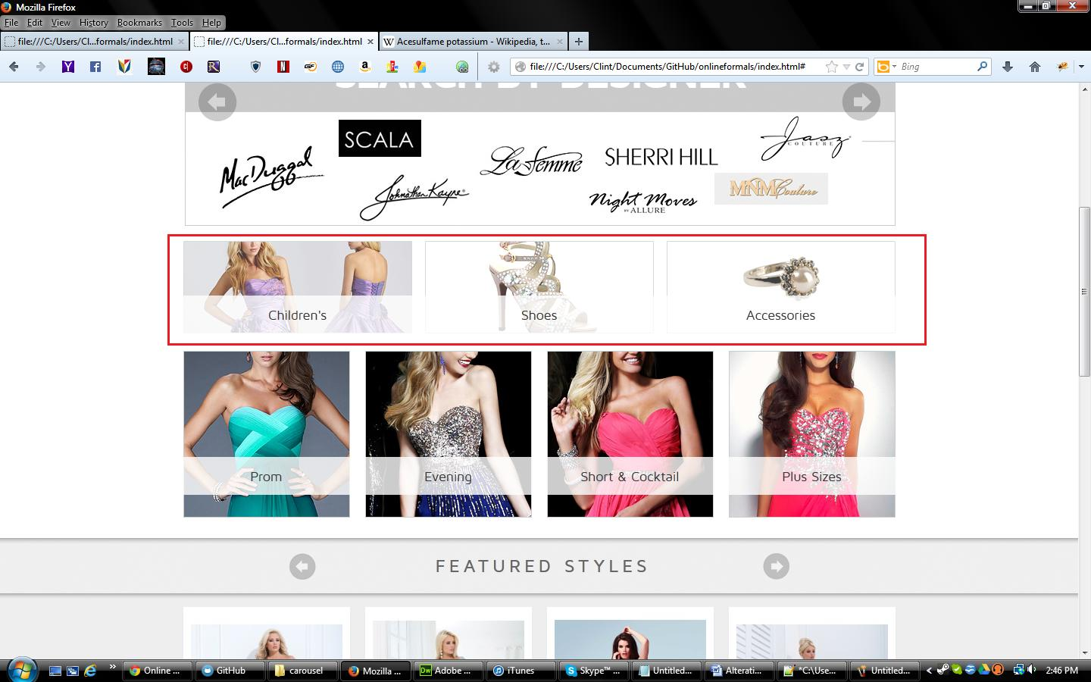

1. In your repo folder, look for a file titled index.html. right-click and/or open this file with your code editor of choice. For notepad++, you should be able to right click the file > open with > notepad++ . Your screen should look something like this:



1. Press ctrl + f. The find feature should come up. Type in homepageSubCatListContainer and hit enter.
2. You should now be in a section that looks something like this. The highlighted area should be the only area you will need to modify:  
   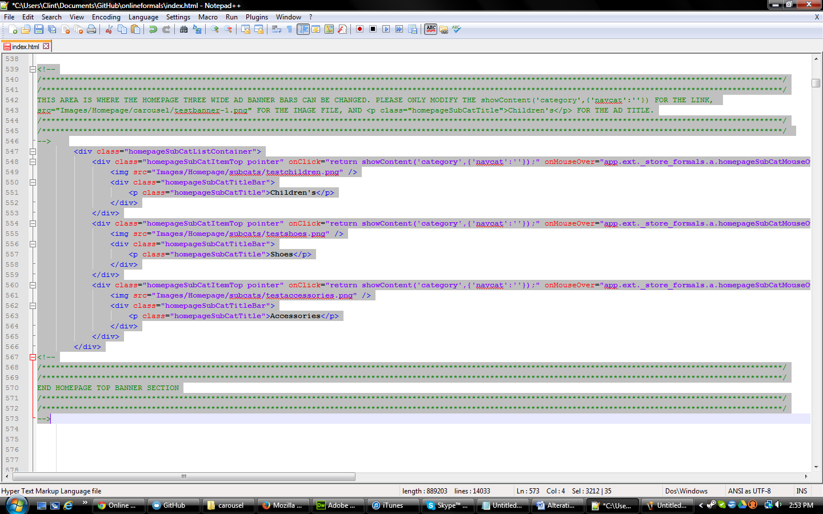
3. To change the banner image and link location:
   1. Open up the following folders: images > Homepage > subcats.
   2. Drop your image file into this folder. Take note of the images name and file type (i.e. .png, .jpeg, etc). Be sure to NOT allow any spaces in the name of this image or your image will not load in the code.
   3. Return to your code editor, press ctrl + f and type in homepageSubCatListContainer and press enter.
   4. To change the link location:
      1. In the <div line, look for a snippet that looks something like this : onClick="return showContent('category',{'navcat':''});" . Where it says: 'navcat':'' add the navigation path for the category page you want displayed. For example, if you wanted the designers.BG Haute category, you would change this line to: 'navcat':'.designers.bg_haute' .
      2. Refer to Proper Syntax section for more instructions on how to change the link for linking to pages other than a category page.
   5. To change the image:
      1. In the <img line, look for a snippet that looks something like this : src=" Images/Homepage/subcats/testchildren.png " . Since you stored your image in the same place that all images go, all you need to change is the testbanner.png (or whatever name is currently there) part of the code. Change this code to whatever your image is named .file type . For example, if the file is called christmasbanner and it is a .png file type, you would input it as christmasbanner.png .
   6. To change the title text:
      1. Locate the line: <p class="homepageSubCatTitle">Children's</p>. Change the Children's part (or whatever text is there) to whatever text you want the title to become.
   7. Your changes are done. Refer to the table of contents for the next section you need to make changes to OR Finishing Your Changes, Saving, and Syncing section if you are completed with your changes.

**Homepage: Four tall ad boxes**

The following steps are for changing the image and link for the Homepage tall ad boxes. The red box indicates where this area is located on the app site:



1. In your repo folder, look for a file titled index.html. right-click and/or open this file with your code editor of choice. For notepad++, you should be able to right click the file > open with > notepad++ . Your screen should look something like this:



1. Press ctrl + f. The find feature should come up. Type in homepageCategoryListContainer and hit enter.
2. You should now be in a section that looks something like this. The highlighted area should be the only area you will need to modify:  
   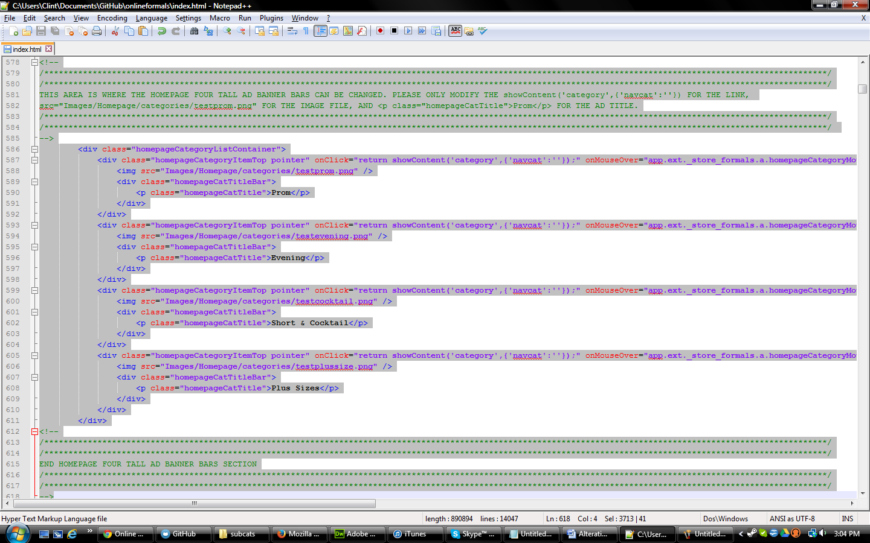
3. To change the banner image and link location:
   1. Open up the following folders: images > Homepage > categories.
   2. Drop your image file into this folder. Take note of the images name and file type (i.e. .png, .jpeg, etc). Be sure to NOT allow any spaces in the name of this image or your image will not load in the code.
   3. Return to your code editor, press ctrl + f and type in homepageCategoryListContainer and press enter.
   4. To change the link location:
      1. In the <div line, look for a snippet that looks something like this : onClick="return showContent('category',{'navcat':''});" . Where it says: 'navcat':'' add the navigation path for the category page you want displayed. For example, if you wanted the designers.BG Haute category, you would change this line to: 'navcat':'.designers.bg_haute' .
      2. Refer to Proper Syntax section for more instructions on how to change the link for linking to pages other than a category page.
   5. To change the image:
      1. In the <img line, look for a snippet that looks something like this : src=" Images/Homepage/categories/testprom.png" . Since you stored your image in the same place that all images go, all you need to change is the testprom.png (or whatever name is currently there) part of the code. Change this code to whatever your image is named .file type . For example, if the file is called christmasbanner and it is a .png file type, you would input it as christmasbanner.png .
   6. To change the title text:
      1. Locate the line: < <p class="homepageCatTitle">Prom</p>. Change the Prom part (or whatever text is there) to whatever text you want the title to become.
   7. Your changes are done. Refer to the table of contents for the next section you need to make changes to OR Finishing Your Changes, Saving, and Syncing section if you are completed with your changes.

**Category Page: Banner Images**

Instructions coming soon!

**Finishing Your Changes, Saving, and Syncing**

Once you have made all the changes you want to do, SAVE YOUR WORK! A simple file > save or ctrl + s will do. After you do that, follow these instructions to complete your changes:

1. Return to your Github client. If you closed it down, follow the getting started steps up to step 4. Your screen should now say it has uncommitted changes in the upper left hand part of the page. It should look something like this:

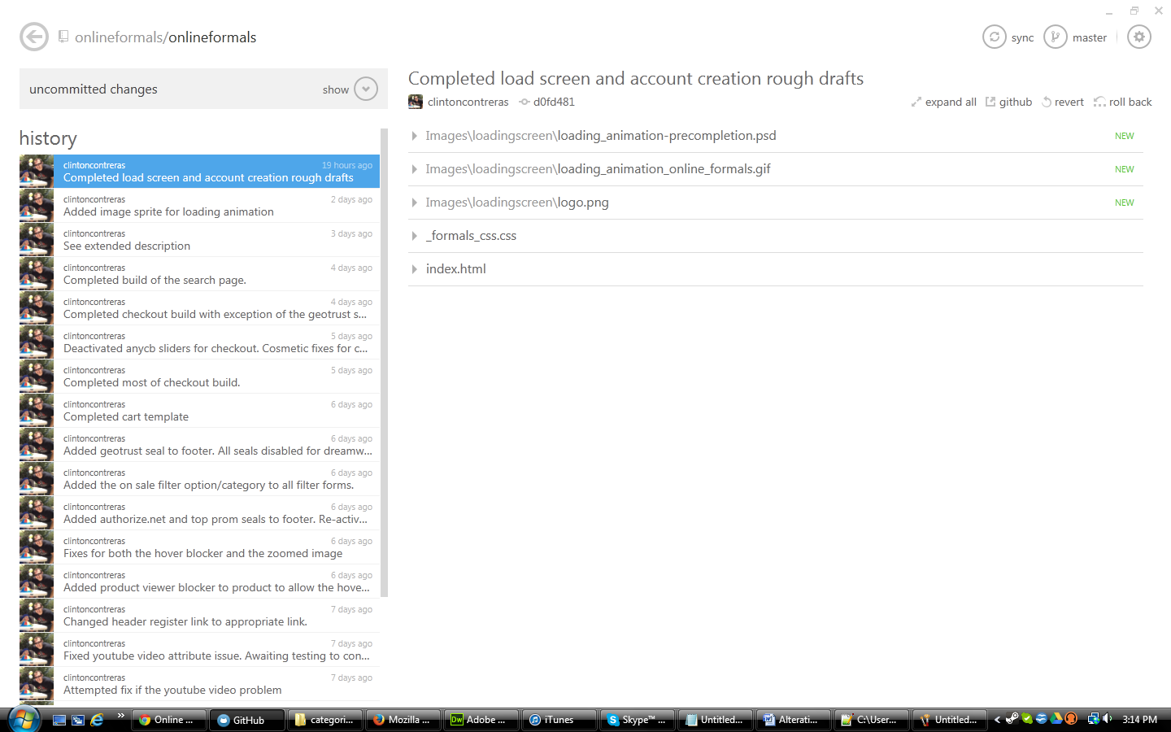

1. Click the show button. Your screen should now display a text entry area and allow you to name your changes, aka, your commit.
2. Enter the description/name of your changes in the commit message area. Once you have finished writing in this description, click the commit to master check button. Your screen should look something like this:

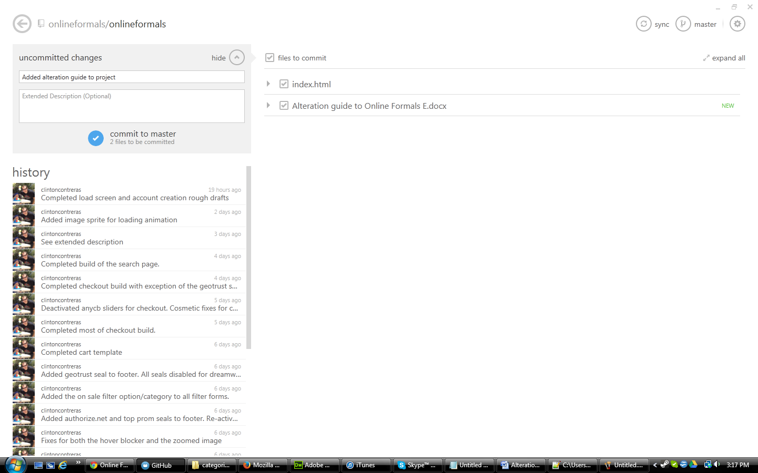

1. Once the commit finishes syncing, your changes have now been added to the master repo.
2. To push your changes to your live site:
   1. Instructions for this step will be added down the line, as the process for doing this has changed and isn’t set in stone just yet. Contact your developer for instructions on how this can be done.

**Proper Syntax For Links**

This section covers the various ways links can be configured to link to the appropriate page. The following is a quick breakdown of how to configure a link to redirect to any kind of page, including category pages:

**display a navigation category page:**

<a href='#top' onClick="return showContent('category',{'navcat':'[.category.safe.name]'});">A Category Name</a>

**cart page:**

<a href='#top' onClick="return showContent('cart',{});">Cart</a>

**product page:**

<a href='#top' onClick="return showContent('product',{'pid':'[pid]'});">A Product Name</a>

**company:**

The company pageType is responsible for loading and displaying content contained in the store 'profile' (a zoovy term). The profile contains policy information for a store, the email address, logo image, and more - the profile code is included in the config.js file. For company links, set the pageType to 'company' and use the list below to set the pageInfo:

<a href='#top' onClick="return showContent('company',{'show':'contact'});">Contact Us</a>

pageType 'company' supports the following standard 'pageInfo.show':

* 'show':'contact' : Contact Us
* 'show':'about' : Company Information
* 'show':'faq' : Frequently Asked Questions
* 'show':'shipping' : Shipping
* 'show':'return' : Return Policy
* 'show':'payment' : Payment Methods
* 'show':'privacy' : Privacy Policy

If you have any further questions regarding how these changes can be made, please contact your project developer to get further instructions.